Madhupur College, Madhupur
A Constituent Unit of S.K.M. University, Dumka
NAAC Grade ‘B’
2.3.2 - Teachers use ICT enabled tools for effective teaching-learning process. Write description in maximum of 200 words
The academic year 2020-21 has been most productive year for using ICT enable tools for effective-learning process due to Covid-19 Lockdown. It has been utilized most effective way and in advanced form of teaching-learning in addition to chalk and talk method of teaching.
Emphasizing on ICT enable tools, the institution makes sure that all the teachers quickly adapt to Online Teaching and Learning. To empower them, the parent University has conducted series of workshops on New Environment, New Requirements, New Technology and Old Method to develop the teaching learning atmosphere more participatory. College encouraged the teachers to adapt this Online Mode of teaching by making use of social media but emphasis on Zoom, Google Meet, Google Classroom, Mentimeter, Google Form and Testmoz.
All the lecture recordings and contents were uploaded on the Subject Google Classrooms and college website as well. Using Google meet app provides effective communication and makes available the E-content at any point of time for the students. College uses the Wi-Fi connection to facilitate this process to each classroom. The online examination, quiz, singing competition, debate, webinars have been conducted through Google Form app in college level for the under graduation students.

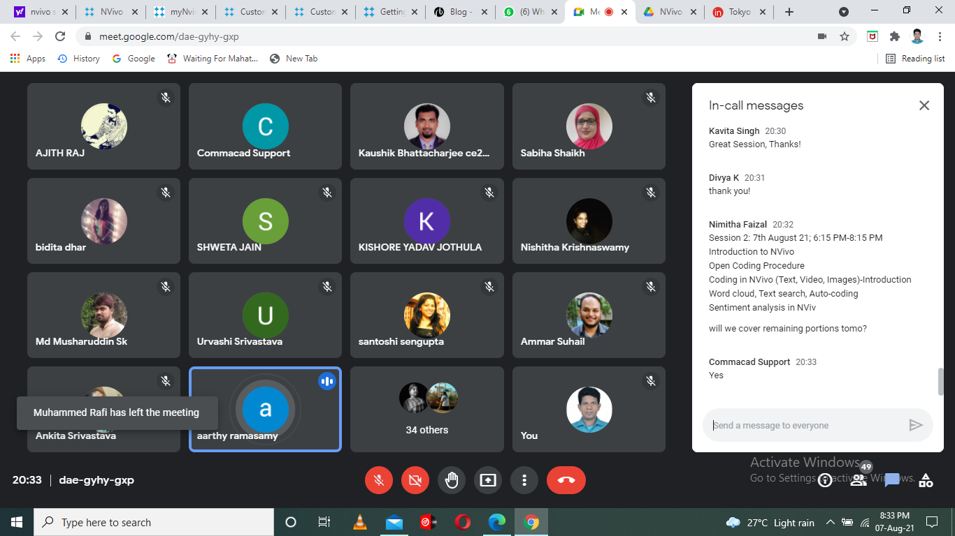
Online Classes during lockdown period with ICT Tools

